EMERGENCY PLANNING FOR CRAFT FARMS RESIDENTS HURRICANE CHECKLIST

TOPIC | PAGE
INITIAL PREPARATION
- Gather your Critical Documents | 3
Tree Branches over Your House | 3
- Document and Inventory Your Property | 4
- Communications | 4
- Prepare Your Home for High Winds and Possible Floods | 5
- Pets | 5
- Prepare an Emergency Supply Kit (People) | 5-6
- Prepare an Emergency Supply Kit (Pets) | 7
- Stay Informed | 8
PREPARE FOR STORM IMPACTS
- If Evacuating  - Gulf Shores Evacuation Routes  - Safety First  - Nearby Shelters | 9  9  9
- If Staying in Place  - Prepare Portable Generators (if on-hand)  - Prepare for Power Outages  - Protect Yourself  - Check on Your Neighbors | 10-11  10  11  11
RECOVERING AFTER THE STORM
11. If Returning from Evacuation  - Health and Safety guidelines  - Before entering your house  - Inside your house | 12  12-13  13
12. If You Stayed and the Storm has Passed  - Ensure Everyone is Safe  - Notify Village Emergency Preparedness POC  - Mitigate Further Damage  - Document Property Damage  - Contact Financial Institutions | 13  13  13  13
13. File an Insurance Claim  a. Start the Clams Process  b. Repairs – Avoid Scams and Fraud  c. Repair Payments  d. Be Suspicious  e. Need Financial Help? | 14-15  15-16  16  16  16
14. Last but not least---a note about Trees | 17
*Sources of Information | 17

EMERGENCY PLANNING FOR CRAFT FARMS RESIDENTS
Checklist details
INITIAL PREPARATION (*1)
1. Gather Your Critical Documents.
Personal Documents (Driver’s License, Social Security cards, Birth Certificates, etc.).
Household identification documents (property deeds or leasing agreements, etc.).
Financial and legal documents (bank statements and paystubs, wills, trusts, etc.).
Medical information and proof of insurance, including medical records and your doctor’s contact information.
Emergency contact information.
Insurance policy(s):
  - Know your insurance coverage - make sure it covers your needs.
  - Understand what your policy protects and under what circumstances.
  - Understand your policy deductibles.
  - Consider additional policies for floods and high winds.
  - Standard insurance policies do not cover flooding.
Keep paper copies of these documents in a fire and waterproof box or safe, in a bank safe deposit box, or with a person you trust.
Keep electronic copies of these documents in a password protected, encrypted format on a removable flash or external hard drive in your fire and waterproof box or safe.

Tree Branches over Your House:
Insurance companies may require that any tree branches that hangs over your roof be removed. The Auburn Extension service recommends contacting a certified Arborist who can provide a letter stating that proper pruning will reduce the hazard from falling and to not butcher the tree.
Contact Joel Potter, potterj@aces.edu or Chuck Owens, City of Gulf Shores, 251-968-5072

2. Document and Inventory Your Property.
Keep a detailed record of your valuable belongings to help you recover and file a claim more quickly. Donna Turner offers the following steps to make a detailed inventory of your home contents (*2).
Room by room home inventory: Tackle one area at a time to avoid feeling overwhelmed. Include attics, basements, storage units and don’t forget the exterior, chimneys, a/c units, pools and generators.
Use technology: Take advantage of apps and software designed for home inventory. A free app, “NAIC Home Inventory” is available on Google Play or Apple store, or simply use your smartphone camera and Notes.
Detail High-Value Items: Pay special attention to expensive items like jewelry, art, and electronics. Note model numbers and serial numbers and keep purchase receipts.
Keep Receipts: Save receipts for major purchases. Digital copies are fine - just be sure they’re backed up in a secure location.
Record Serial Numbers: For electronics and appliances, serial numbers are crucial for identification and claim processing.
Video Walkthrough: Create a video inventory by walking through your home and narrating the details of your belongings.
Update Inventory Regularly: Make a habit to update your inventory annually. May 1 is a good date, giving you 30 days before the start of hurricane season.
Share with your insurer: Let your insurance company know you have a detailed inventory.
Keep your inventory on a portable computer drive like a CD or flash drive, in online remote storage like a cloud storage system, in an electronic file, or written down on paper.
Keep your inventory somewhere away from your home where it can be accessed after a disaster.

3. Communications.
Ensure the POA office has your current email address and phone number. This is how any relevant information before and after the emergency will be sent out.
Your Village Rep will advise you of the Village specific plans for communications.
4. Prepare Your Home for Both High Winds and Possible Flooding
Declutter drains and gutters.
Install check valves in plumbing to prevent backups.
Trim or remove damaged tree limbs on your property.
Remove any objects that may become flying debris (tables, fire pits, lawn furniture, etc.)
Inspect your roof, windows, and doors to ensure they work properly.

5. Pets.
Most emergency shelters near here do not accept pets.
Arrange a safe haven if you must evacuate.
Ask your Vet for a list of preferred boarding kennels available in the event of emergency.
Check with local animal shelters to see if they provide temporary emergency shelter.
For example: Parker Kennels in Foley at 251-970-3647
Chose a designated caregiver outside of the Baldwin County area.
Check WWW.PETSWELCOME.COM FOR HOTELS THAT ACCEPT PETS.

5. Prepare an Emergency Supply Kit (People).
Prepare several emergency supply kits.
Store emergency supplies in different places, such as your home, office, and vehicle.
Water: Keep 1 gallon of drinking water, per person, per day. Consider 3, 7, or even 14 days of water on hand.
Food: Keep 96 hours’ worth of non-perishable food, like cans and dry goods, per person on hand.
Cash:
  - Keep enough cash on hand to buy food, fuel, and a few nights in a hotel if you must evacuate.
  - Keep a mixture of $1s, $5s, and $10s, nothing larger than a $20.
  - Include cash enough to board your pet at an animal shelter.
Emergency Radio: Battery-powered or hand crank radio and a National Oceanic and Atmospheric Administration (NOAA) All Hazards Weather Radio with tone alert—keep extra batteries for both.
1 Flashlight and Whistle per family member with extra batteries.
First aid kit.
N95 respirator masks - these may keep you safe from smoke and chemicals. Keep several in your kit and fit test each mask to ensure a tight seal on the face.
Wrench or pliers to turn off utilities.
Can opener and other food preparation tools.
Local maps.

Other items you may want to add to your emergency supply kit:
Prescription medications and glasses.
Infant formula and diapers.
Emergency reference material (e.g., a first aid book).
Sleeping bag or warm blanket for each person.
Complete change of clothing, including a long-sleeved shirt, long pants, and sturdy shoes.
Water purification system.
Fire extinguisher.
Personal feminine hygiene products.
Camping mess kits for cooking, paper cups, plastic plates and utensils, and paper towels.
Paper and pencil.
Cleaning supplies, soap, and hand sanitizer that has at least 60% alcohol.

7. Prepare an Emergency Supply Kit (Pets).
Make two kits:
- Stay at Home Kit: One kit has everything your pet will need to stay home.
- Evacuation Kit: A lightweight, smaller version you can take with you if you must evacuate.
Water: At least 4 days’ worth.
Food: At least 4 days’ worth in a water-proof container.
Medicines: Keep extra supply in a waterproof container.
Collar with ID tag and leash: Include a backup tag and leash.
First aid kit: Your vet should advise you what would be appropriate for your pet.
Crate/Pet Carrier: Should be l large enough for your pet to stand, turnaround & laydown.
Picture of you and your pet together: If you get separated, this will help document ownership.
Familiar items: Toys or bedding to help reduce stress.
Important documents: Vaccinations, med records, vet info etc., in a waterproof container.
Sanitation: Include newspapers, paper towels. Plastic trash bags, shampoo, bleach, litter and box.

Evacuation Preparation.
Store the emergency kit as close to an exit as possible.
Make sure all pets are wearing collars with current identification
Always bring pets indoors at the first warnings of a storm.
Consider your evacuation route and call ahead to make arrangements for boarding your pet outside the disaster area.
Check www.petswelcome.com for hotels that accept pets.

8. Stay Informed.
Check the Baldwin 911.net site to check for road closures.
Download the Baldwin County Commission app. This app will allow you to access the Baldwin EMA for news and information.
Sign up for www.AlertBaldwin.com to receive updates.
Sign up for City of Gulf Shores notifications.
Find out where Jim Cantore is!
KEEP YOUR CAR’S GAS TANK FULL! When it hits 2/3 full, top it off!
Decide to Evacuate or Stay Here: Decide at least 48 hours before expected heavy weather to avoid heavy rain and winds.
TEXT your Village Emergency Preparedness POC of your decision!

PREPARE FOR STORM IMPACTS.
9. If Evacuating:
CRITICAL INFORMATION:
If told to evacuate, do so immediately.
If evacuating voluntarily, don’t wait once you have made your decision – go!
The closest shelter is in Robertsdale (see below for information).
- Gulf Shores Evacuation Routes:
- Highway 59 North.
- Foley Beach Express and Baldwin Beach Express.
Craft Farms is In Evacuation Zone 2.
- Safety First:
- Do not drive around barricades.
- When you come across flooded roadways: Turn Around, Don’t Drown.
- 6 inches of moving water may be enough to knock you off your feet.
- As little as 12 inches of moving water may lift a small vehicle.
- Nearby Shelters:
- Baldwin County Coliseum: 19477 Fairground Rd, Robertsdale, Al 36567
- Bay Minette Middle School: 1311 West 13th Street, Bay Minette AL 36507
- Medical Needs Shelter: Baldwin County Coliseum, 19477 Fairground Rd, Robertsdale, Al 36567
- NOTE: These shelters DO NOT accept pets.
Baldwin County Coliseum:
- Will provide 3 meals per day.
- Has laundry, restroom, and showers facilities.
- Residents will need to register and have a photo ID.
- Bring important papers, personal care items, sleeping bags, blankets, and pillows.
- Security will also be provided at the shelter.

10. If Staying in Place:
CRITICAL INFORMATION:
- Prepare Portable Generator(s) (if you have one):
Calculate how many hours/day you will run the generator.
Know the number of hours your generator will run per gallon (Example: Generator will run for 8 hours at full load on 5 gallons gas).
Buy the amount needed to supply your need for X days.
Ensure fuel is stored in approved storage containers.

- Prepare for Power Outages:
Inventory the items you need that rely on electricity. Make backup plans if you have medical equipment that is dependent on power.
Keep mobile phones and any battery-powered devices charged and have backup charging methods such as a car charger.
Only use flashlights for lighting:
- Using candles could be a fire hazard.
- Have at least 1 flashlight with extra batteries per household member.
Turn off or disconnect appliances and other equipment to protect them from quick power surges.
Whenever possible, use surge protectors.
Avoid carbon monoxide poisoning:
- Keep generators, camp stoves, or charcoal grills outdoors and at least 20 feet away from windows.
- If you use your car to charge devices, do not leave the car running in a garage, partly closed space, or near a home.
Keep perishable food cold to avoid illness.
- Keep a thermometer in your refrigerator and freezer to monitor the temperature.
- When in doubt, throw it out!
- Throw away any food that has been exposed to temperatures 40 degrees or higher for 2 hours or more, or that has an unusual odor, color, or texture.
- If the power is out for more than a day, discard any medication that should be refrigerated, unless the drug’s label says otherwise.

- Protect Yourself:
If trapped in a building by flooding, go to the highest level of the building. Do not climb into a closed attic - you may become trapped by rising flood water.
- Check on Your Neighbors:
Older adults and young children are especially vulnerable to extreme temperatures.

RECOVERING AFTER THE STORM -TAKE LOTS OF PICTURES (*3)
11. If Returning from Evacuation:
a. Health and Safety Guidelines.
During disaster cleanup:
- Beware of exhaustion.
- Do not try to do too much at once: set priorities, pace yourself, and take breaks for rest.
- Wear sturdy work boots and gloves and wash your hands thoroughly with soap and clean water often when working in debris.
Notify your POA Village Damage Assessment POC know about health and safety issues, including:
- Chemical spills
- Contaminated buildings
- Contaminated water
- Gas leaks
- Broken glass
- Damaged electrical wiring/downed power lines
- Washed-out roads
- Smoldering insulation
- Dead animals
Assume any downed power lines are live:
- Downed power lines can energize the ground up to 35 ft. away - keep your distance.
- Never drive over a downed line or through water that’s touching the line.
- Notify the local authorities immediately.
- Never try to move a downed power line even if you think it’s deenergized.

- Before You Enter Your Home:
Carefully walk around the outside and check for loose or downed power lines, gas leaks, and/or structural damage.
If your house has been damaged, a qualified inspector should check to be sure it is safe to enter and occupy.

- Inside Your Home:
Natural Gas:
If you smell gas or hear a hissing or blowing sound: DO NOT FLIP ANY LIGHT SWITCH, open a window and leave immediately.
DO NOT USE ANY FLAMMABLES.
Sparks, Broken, Or Frayed Wires: Do not check the electrical system if you are wet, standing in water, or unsure of your safety.
Roof, Foundation, And Chimney Cracks: Do not enter a building that shows any sign of structural damage like cracks in the walls, windows and doors out of square, or shifts in the foundation.
Appliances: Have appliances checked by a professional before using them again. Have the electrical system checked by an electrician before turning the power back on.
Water and Sewage Systems: Check with your Village Emergency Preparedness POC or Gulf Shores Utilities that your water is safe to drink
Pests or Vermin: Be aware of potential pest problems, such as mice, rats, insects, or snakes that may have come with the storm. Contact your Village Emergency Preparedness POC for help.

12. If You Stayed and the Storm has Passed:
- Ensure that everyone is safe and that no hazards are present:
- Gas.
- Water.
- Electricity.
- Notify your Village Emergency Preparedness POC of your status.
- Mitigate further damage: Take steps to prevent the property from suffering further damage. For example, if a storm has broken doors or windows, you should make temporary repairs to prevent further damage. Or if there is a damaged water or gas line, turn them off.
- Document Property Damage: Take lots of pictures and videos of any damage to your property. (3*)
- Contact your financial institutions regarding your situation: credit cards, bank cards, mortgage company, etc.

13. File an Insurance Claim:
a. Start the Claims Process: Contact with Your Insurance Company
Act quickly to make the claims process go smoothly.
Have the necessary information handy, including your policy number and a telephone and/or email address where you can be always reached.
Be sure to ask them of the specific requirements they need to process your claim.
Your adjuster will assist you in preparing Proof of Loss, which is your sworn statement of the amount you are claiming including necessary supporting documentation.
A “Proof of Loss” can contain many things but must include the specific details set forth in your insurance policy.
- Document every communication you have with insurance adjusters and representatives.
- Keep a list of their names, contact information and the time and date of each call. Safely store all paper documents.
- Inventory all damaged and undamaged property (use your inventory record).
Don’t discard damaged property, unless instructed by authorities or your insurance company.
Even if the property is a mess, ensure it stays at the location until an adjuster has inspected it. Otherwise, the insurance company will claim there is no proof!
Do not admit you were to blame for any of the damage.
Some adjusters may try to trick you into admitting fault, such as leaving a door or window open during the storm. Be wary of them!
Never ever assume your insurer’s calculations are correct.
- You can always question the calculations.
- You can receive your own repair quotes and you can question it all.
- You have a right to do so!
Most Insurance companies will inform you that the case is closed once they pay you.
You can reopen a claim so long as you did not sign a full and final settlement release.
Insurance adjusters may try to manipulate you or shut you out. If so, hire a property damage attorney for aggressive professional representation.
Make sure you have met all insurance requirements.
If your home is severely damaged and you need to find somewhere else to stay while repairs are made, keep records and receipts of all extra expenses you incur (e.g., hotel and restaurant expenses).

b. Repairs – Avoid Scams and Fraud:
Protect your personal information (Social Security number, bank accounts, etc).
The minute you return home, you will be assailed by contractors wanting to repair your damage. (3*)
- Avoid door-to-door solicitors.
- Verify their credentials independently.
- Don’t be rushed into any agreement - Beware “limited-time” offers.
- Ensure sure the contractor(s) you use for repairs is licensed by the City of Gulf Shores. To verify a contractor’s license:

- Call the City Revenue Department at 251-968-2426.
- Check the Craft Farms website for a List of City of Gulf Shores, Licensed Contractors who have worked in Craft Farms Understand a business license is not an endorsement or guarantee of quality work.
- Ask for references and clearly define the scope of the work and payment terms.

- Don’t be rushed or pressed to make a hasty decision. Do your due diligence before hiring a contractor.
- Craft Farms POA will not sanction nor be responsible for any listed vendor.
Verify contractor’s license by:
- Calling the Alabama Home Builders Licensure Board at 800-304-0853 or https://hblb.Alabama.gov. This will verify if the contractor is legitimate and capable.
- Check their references, they should have at least 3.
- Call the Alabama Attorney General’s office to investigate any complaints filed against the Contractor.
- Recommend taking a picture of the Contractor’s license & ID.
If they can meet the above requirements and you agree on terms get a written contract that documents (*4):
- Contractor’s license number
- Terms of guarantees and warranties
- Finance charges
- Payment schedule
- Specific start and finish dates
Contractors are required to get a building permit from the City of Gulf Shores in their name before any repairs are begun.
If /Contractors try to pressure you to get the repairs done, call the police.

c. Repair Payments:
DO NOT pay any contractor up front.
However, it is typical and often necessary for contractors to request 10-25% for materials.
Use credit card or check keeping records of all transactions
Release final payment Only after all work is satisfactorily completed and all sub-contractors are fully paid.

- Be Suspicious:
Government workers do not ask for or accept money.
Always ask for official laminated photo ID rom people claiming to be working for an official organization.
A FEMA shirt or U.S. Small Business Administration (SBA) jacket is not absolute proof of identity.
Report suspicious activity to local authorities and the FEMA Disaster Fraud Hotline at 1-866-720-5721.

- Need Financial Help?
Now that you’ve got all the above done, it’s time to touch base with “DisasterAssistance.com” to find out if you’re qualified for financial disaster relief. (*5)

14. Last but not least---a note about Trees:
If a tree has fallen on your property, it is your responsibility to have it removed.
If that tree is a signature tree, the CFPOA will bear the cost of removal.
However, the CFPOA will not reimburse a resident who pays for the removal of a signature tree without first getting approval of the CFPOA for the contractor and cost of removal.

Sources of Information*
*1 “Emergency Finance First Aid Kit”, FEMA Publication P-1075 Sep 2019. At “Ready.gov/financial-preparedness” This booklet supplies extensive information on safeguarding your financial information during an emergency.
*2 “10 ways to make a home inventory before disaster strikes” and “Mistakes you should never make when filing a homeowner insurance claim”- Donna Turner, June 4, 2024. Dkturner55@gmail.com
*3 “Don’t Goof when you Re-roof” at “DontGoof.com”. Very useful checklist when you’re recovering from an emergency to avoid contractor fraud.
*4 “Baldwin County DA Office’s guide to preventing post hurricane fraud’ by Whisper Edwards, Editorial Assistance, “Whisper@gulfcoastmedia.com”
*5 “DisasterAssistance.gov” Determine if you can get financial aid from FEMA.
(6) If you need help finding an insurance provider, go to FloodSmart.gov/flood-insurance-provider or call the NFIP at 877-336-2627.

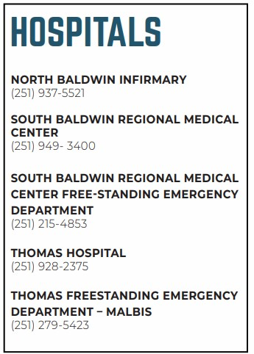
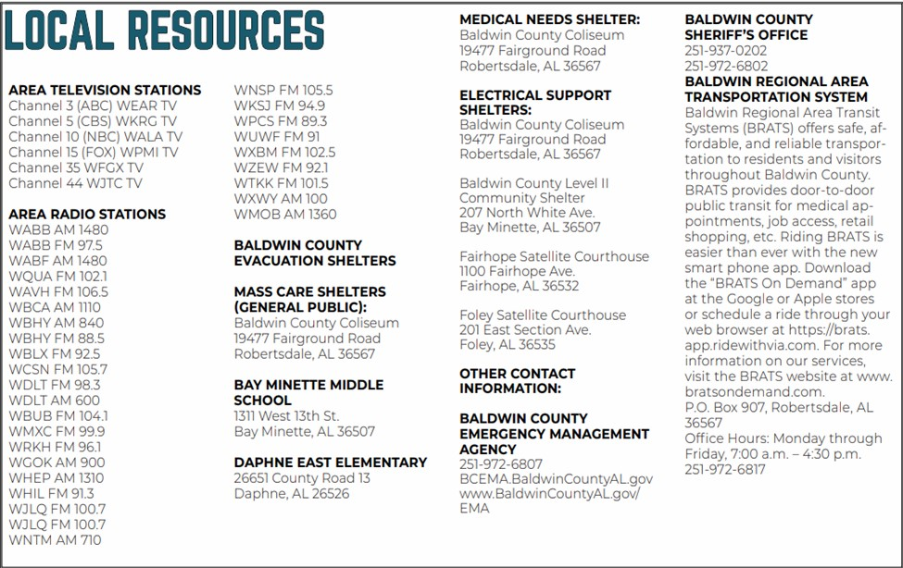

(Village)
EMERGENCY PREPAREDNESS ORGANIZATION--

